Industrial Internship Report on
”Project Name”
Student Performace Prediction
Submitted By
[Saniya Ali]

Executive Summary
This report provides details of the Industrial Internship provided by upskill Campus and The IoT Academy in collaboration with Industrial Partner UniConverge Technologies Pvt Ltd (UCT).
This internship was focused on a project/problem statement provided by UCT. We had to finish the project including the report in 6 weeks’ time.
The project, Student Performance Prediction Using Machine Learning, aims to predict a student's academic performance using factors such as study hours, attendance, previous marks, and assignment scores. A Linear Regression algorithm was implemented using Python and the Scikit-learn library to build the prediction model.
This internship improved my knowledge of Python programming, data analysis, machine learning algorithms, and GitHub project management while providing practical experience with the complete machine learning workflow.

TABLE OF CONTENTS
1 Preface 3
2 Introduction 4
2.1 About UniConverge Technologies Pvt Ltd 4
2.2 About upskill Campus 9
2.3 Objective 11
2.4 Reference 11
2.5 Glossary 11
3 Problem Statement 12
4 Existing and Proposed solution 13
5 Proposed Design/ Model 14
5.1 High Level Diagram (if applicable) 14
5.2 Low Level Diagram (if applicable) 15
5.3 Interfaces (if applicable) 16
6 Performance Test 17
6.1 Test Plan/ Test Cases 17
6.2 Test Procedure 17
6.3 Performance Outcome 17
7 My learnings 18
- Future work scope 19

Preface

Industrial internships play a significant role in bridging the gap between academic knowledge and practical industry experience.

During this six-week internship organized by upskill Campus in collaboration with UniConverge Technologies Pvt. Ltd. (UCT), I gained practical exposure to the fundamentals of Data Science and Machine Learning.
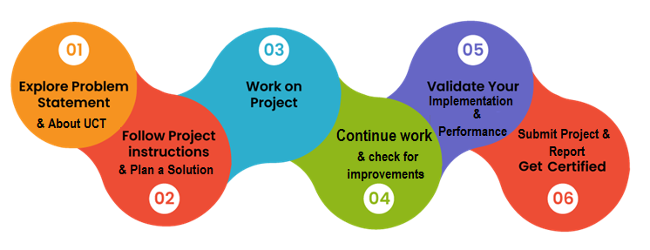
The internship enhanced my technical skills in Python, data analysis, GitHub, and machine learning while improving my problem-solving and analytical thinking.
I sincerely thank the mentors from upskill Campus, UniConverge Technologies Pvt. Ltd., for their continuous guidance and support.

Introduction

About UniConverge Technologies Pvt Ltd
A company established in 2013 and working in Digital Transformation domain and providing Industrial solutions with prime focus on sustainability and RoI.
For developing its products and solutions it is leveraging various Cutting Edge Technologies e.g. Internet of Things (IoT), Cyber Security, Cloud computing (AWS, Azure), Machine Learning, Communication Technologies (4G/5G/LoRaWAN), Java Full Stack, Python, Front end etc.

- UCT IoT Platform ()
UCT Insight is an IOT platform designed for quick deployment of IOT applications on the same time providing valuable “insight” for your process/business. It has been built in Java for backend and ReactJS for Front end. It has support for MySQL and various NoSql Databases.
- It enables device connectivity via industry standard IoT protocols - MQTT, CoAP, HTTP, Modbus TCP, OPC UA

- It supports both cloud and on-premises deployments.
It has features to
• Build Your own dashboard
• Analytics and Reporting
• Alert and Notification
• Integration with third party application(Power BI, SAP, ERP)
• Rule Engine

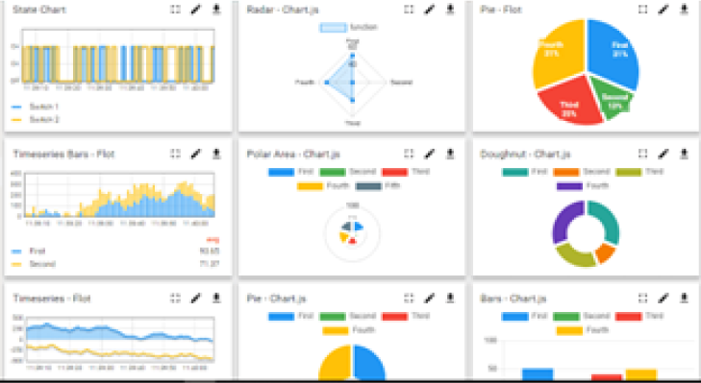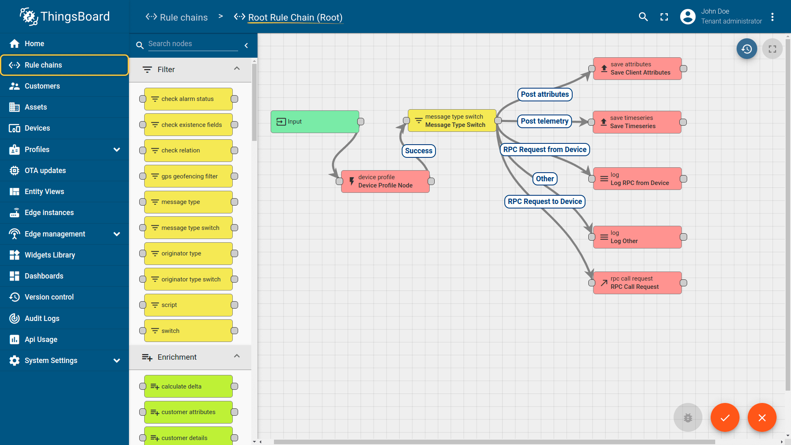

- Smart Factory Platform ()

Factory watch is a platform for smart factory needs.
It provides Users/ Factory
- with a scalable solution for their Production and asset monitoring
- OEE and predictive maintenance solution scaling up to digital twin for your assets.
- to unleased the true potential of the data that their machines are generating and helps to identify the KPIs and also improve them.
- A modular architecture that allows users to choose the service that they what to start and then can scale to more complex solutions as per their demands.
Its unique SaaS model helps users to save time, cost and money.
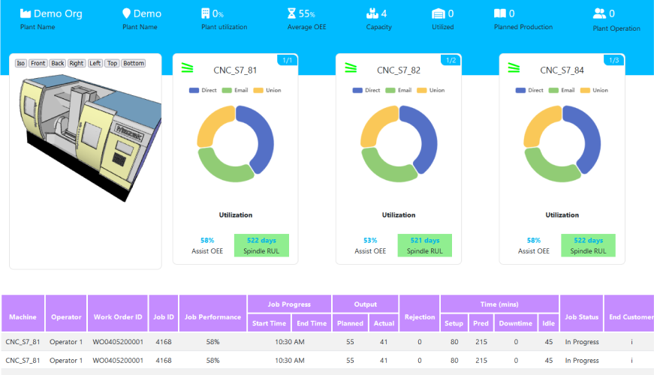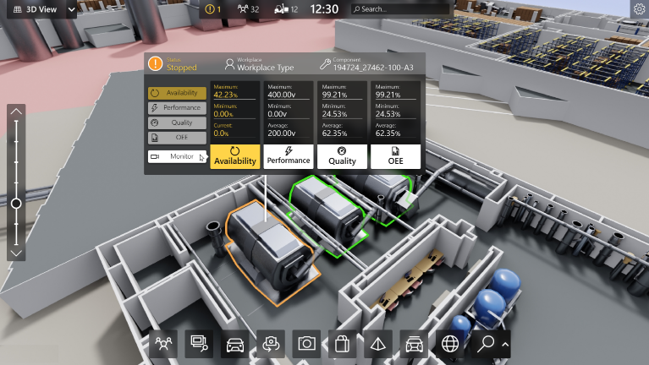

- 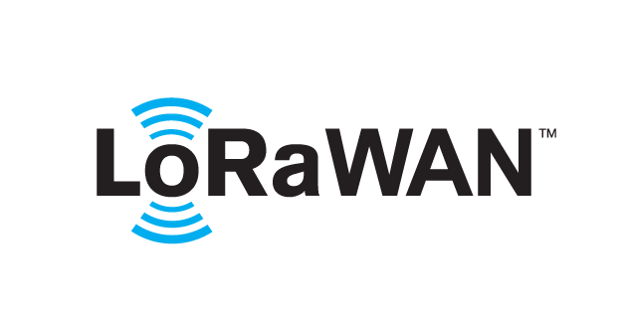 based Solution
UCT is one of the early adopters of LoRAWAN teschnology and providing solution in Agritech, Smart cities, Industrial Monitoring, Smart Street Light, Smart Water/ Gas/ Electricity metering solutions etc.
- Predictive Maintenance
UCT is providing Industrial Machine health monitoring and Predictive maintenance solution leveraging Embedded system, Industrial IoT and Machine Learning Technologies by finding Remaining useful life time of various Machines used in production process.
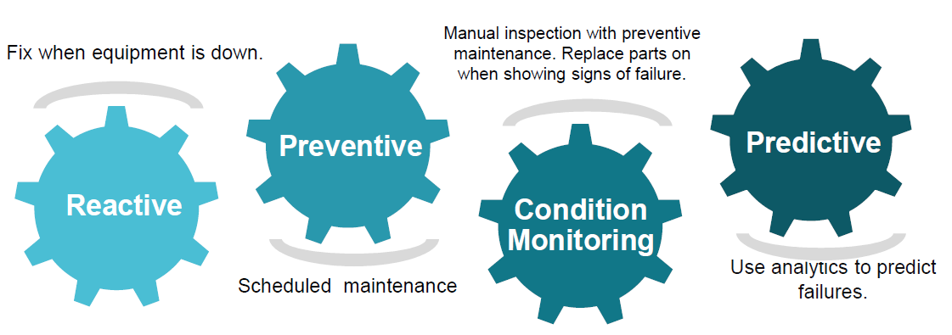

About upskill Campus (USC)
upskill Campus along with The IoT Academy and in association with Uniconverge technologies has facilitated the smooth execution of the complete internship process.
USC is a career development platform that delivers personalized executive coaching in a more affordable, scalable and measurable way.

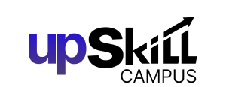


Seeing need of upskilling in self paced manner along-with additional support services e.g. Internship, projects, interaction with Industry experts, Career growth Services
https://www.upskillcampus.com/
upSkill Campus aiming to upskill 1 million learners in next 5 year

2.3 Objectives of this Internship program
The objective for this internship program was to
☛ get practical experience of working in the industry.
☛ to solve real world problems.
☛ to have improved job prospects.
☛ to have Improved understanding of our field and its applications.
☛ to have Personal growth like better communication and problem solving.

2.4 Reference
The following resources were used during the project:
Python Official Documentation – https://docs.python.org⁠
Scikit-learn Documentation – https://scikit-learn.org⁠
Pandas Documentation – https://pandas.pydata.org⁠

2.5 Glossary
Terms | Acronym
AI | Artificial intelligence
ML | Machine Learning
DS | Data Science
Python | Programming Language
GitHub | Version Control Platform

Problem Statement

Educational institutions often face challenges in identifying students who are at risk of poor academic performance. Traditional evaluation methods rely on manual observation and periodic examinations, which may not provide early insights into student progress.

The objective of this project is to develop a Student Performance Prediction System using Linear Regression. The system predicts student performance based on important academic factors such as:

Study Hours
Attendance Percentage
Previous Examination Marks
Assignment Scores

The developed model assists educators by providing early predictions of student performance, allowing timely interventions and personalized academic support.

Existing and Proposed solution

Existing Solution
Most educational institutions evaluate students primarily through periodic examinations and manual analysis of academic records. This process can be time-consuming and may not accurately predict future performance. It also lacks the ability to identify at-risk students at an early stage.
  - Limitations
- Manual evaluation requires significant effort.
- Predictions are based on limited information.
- Early identification of struggling students is difficult.
Proposed Solution
The proposed system uses Machine Learning (Linear Regression) to analyze student-related data and predict academic performance automatically.
- The system performs the following tasks:
- Loads the student dataset.
- Cleans and preprocesses the data.
- Predicts student marks based on input features.
- Evaluates model performance.
- Displays prediction results and visualizations.

Code submission (Github link)
https://github.com/Saniya0131/upskillCampus/blob/main/StudentPerformancePrediction.py

Report submission (Github link) :
https://github.com/Saniya0131/upskillCampus/blob/main/StudentPerformancePrediction_SaniyaAli.pdf

Proposed Design/ Model

The Student Performance Prediction System follows the standard Machine Learning workflow. Student academic data is collected, cleaned, processed, and then used to train a Linear Regression model. After training, the model predicts student performance based on new input values.

High Level Diagram (if applicable)
Student Dataset
▼
Data Preprocessing
▼
Feature Selection
▼
Linear Regression Model Training
▼
Performance Prediction
▼
Model Evaluation & Results

Figure 1: HIGH LEVEL DIAGRAM OF THE SYSTEM

Low Level Diagram (if applicable)
Student Dataset (.csv)
▼
Read Dataset using Pandas
▼
Handle Missing Values
▼
Select Features
(Study Hours, Attendance,
Previous Marks, Assignment Score)
▼
Split Dataset
(Training & Testing)
▼
Train Linear Regression Model
▼
Predict Student Marks
▼
Calculate Accuracy
▼
Display Graph & Output

Interfaces (if applicable)

Student Dataset (CSV)
▼
Load Dataset using Pandas
▼
Train Linear Regression Model
▼
Enter Student Details
▼
Predict Final Marks
▼
Display Prediction & Performance Graph

Performance Test

Performance testing was carried out to evaluate the effectiveness of the Student Performance Prediction model. The trained Linear Regression model was tested using unseen student records from the testing dataset.

Test Plan/ Test Cases
Test Case | Input | Expected Result | Status
TC-1 | Load dataset | Dataset loaded successfully | Pass
TC-2 | Clean dataset | Missing values removed | Pass
TC-3 | Train Model | Model trained successfully | Pass
TC-4 | Predict Marks | Predicted marks generated | Pass
TC-5 | Evaluate Model | Accuracy calculated | Pass

Test Procedure
- Import required Python libraries.
- Load the student dataset.
- Preprocess and clean the data.
- Split the dataset into training and testing sets.
- Train the Linear Regression model.
- Predict marks for the testing dataset.
- Compare predicted values with actual values.
- Evaluate the model using R² Score, Mean Absolute Error (MAE), and Mean Squared Error (MSE).

Performance Outcome
The Linear Regression model successfully predicted student performance using the selected academic features.
SAMPLE RESULTS:
METRIC | RESULT
Algorithm | Linear Regression
Training data | 80%
Testing data | 20%
Mean squared Error | Low
R^2 Score | Good Prediction Accuracy

7 My learnings

During this internship, I gained practical knowledge of Data Science and Machine Learning by working on a real-world project.
I learned how to collect and preprocess datasets, build a Linear Regression model, evaluate its performance, and interpret the results.

The internship also improved my Python programming skills and introduced me to important libraries such as Pandas, NumPy, Matplotlib, and Scikit-learn. I learned how to use GitHub for version control and project submission.

In addition to technical skills, I improved my analytical thinking, problem-solving ability, documentation skills, and confidence in developing machine learning applications.
This internship has motivated me to continue learning advanced concepts in Artificial Intelligence and Data Science.

8 Future work scope

The Student Performance Prediction system can be further improved in several ways:

- Use larger and more diverse datasets for better accuracy.

- Apply advanced algorithms such as Random Forest, XGBoost, or Neural Networks.

- Develop a web-based application for teachers and students.

- Integrate real-time student attendance and examination databases.

- Add personalized recommendations for improving student performance.

- Deploy the model on cloud platforms for online access.

- Implement dashboards for visualizing student performance trends.

These enhancements can make the system more accurate, scalable, and useful for educational institutions.

Conclusion

The Student Performance Prediction Using Machine Learning project successfully demonstrated how data science techniques can be applied to solve a real-world educational problem.

By implementing a Linear Regression model, the system can predict student performance based on academic factors such as study hours, attendance, previous marks, and assignment scores.

The project enhanced my understanding of the complete machine learning lifecycle, including data preprocessing, model training, evaluation, and prediction. Overall, this internship provided valuable practical experience and strengthened my technical and professional skills.

